Báo cáo thực hành

Lập trình hướng đối tượng

Thứ 7,ngày 28 tháng 9 2024

Exercise 1: Write, compile and run the ChoosingOption program:

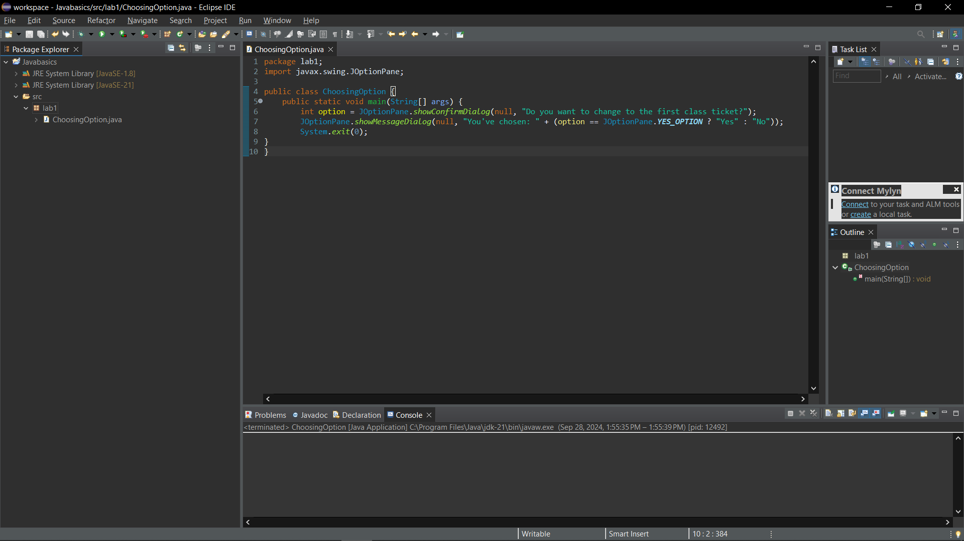

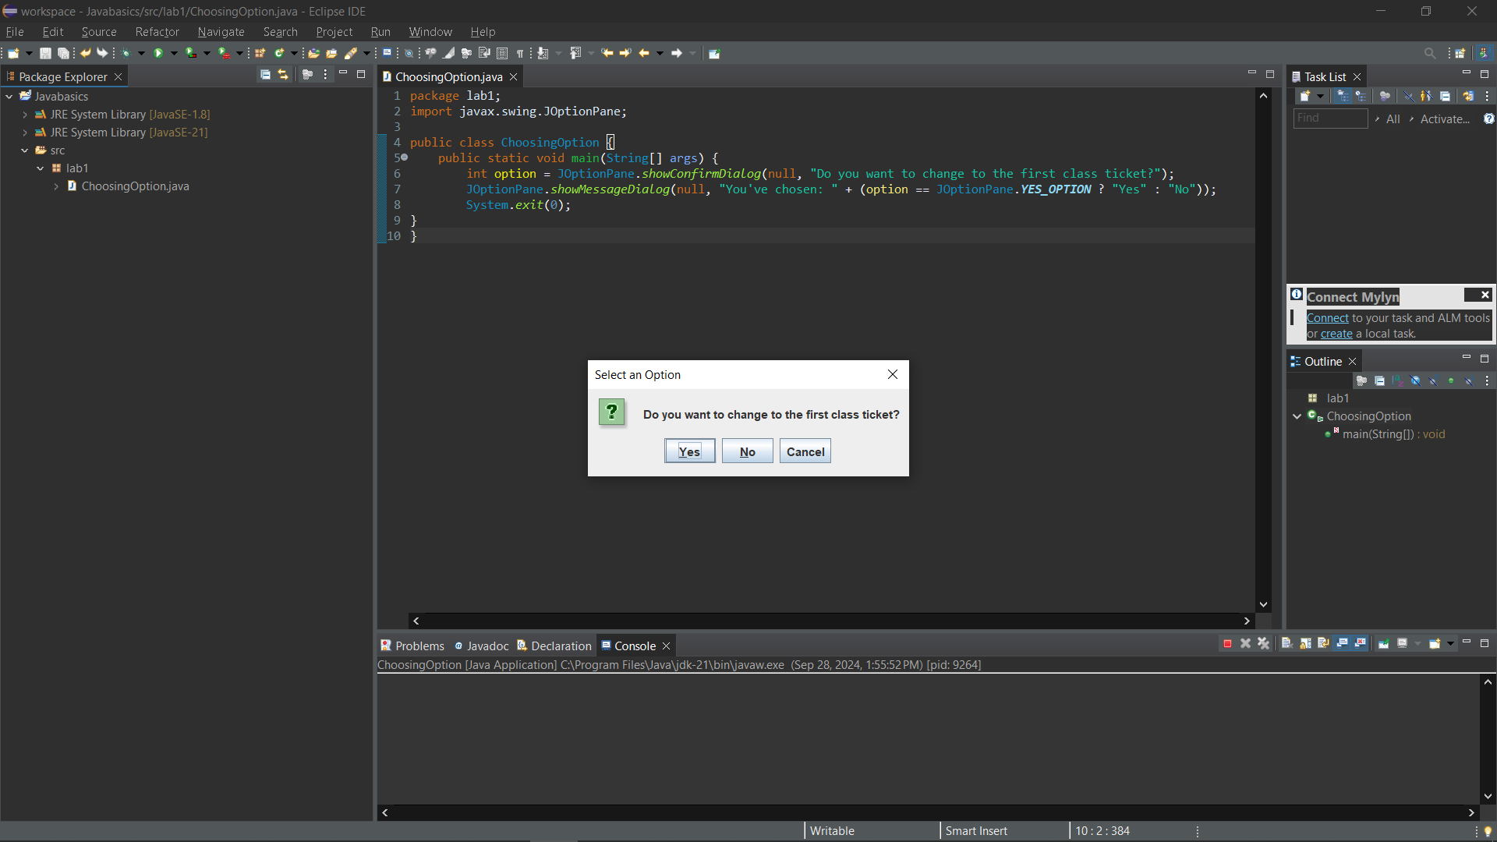

Questions:

- What happens if users choose “Cancel”: A message box appear and say that “You’ve chosen: NO”

- How to customize the options to users, e.g. only two options: “Yes” and “No”, OR “I do”

and “I don’t” (Suggestion: Use Javadocs or using Eclipse/Netbean IDE help):

1. Use [JOptionPane.showOptionDialog](vscode-file://vscode-app/c:/Users/domin/AppData/Local/Programs/Microsoft%20VS%20Code/resources/app/out/vs/code/electron-sandbox/workbench/workbench.html) to create a dialog with custom options.
2. Define the options you want to display.
3. Handle the user's choice accordingly.

Exercise 2: Write a program for input/output from keyboard

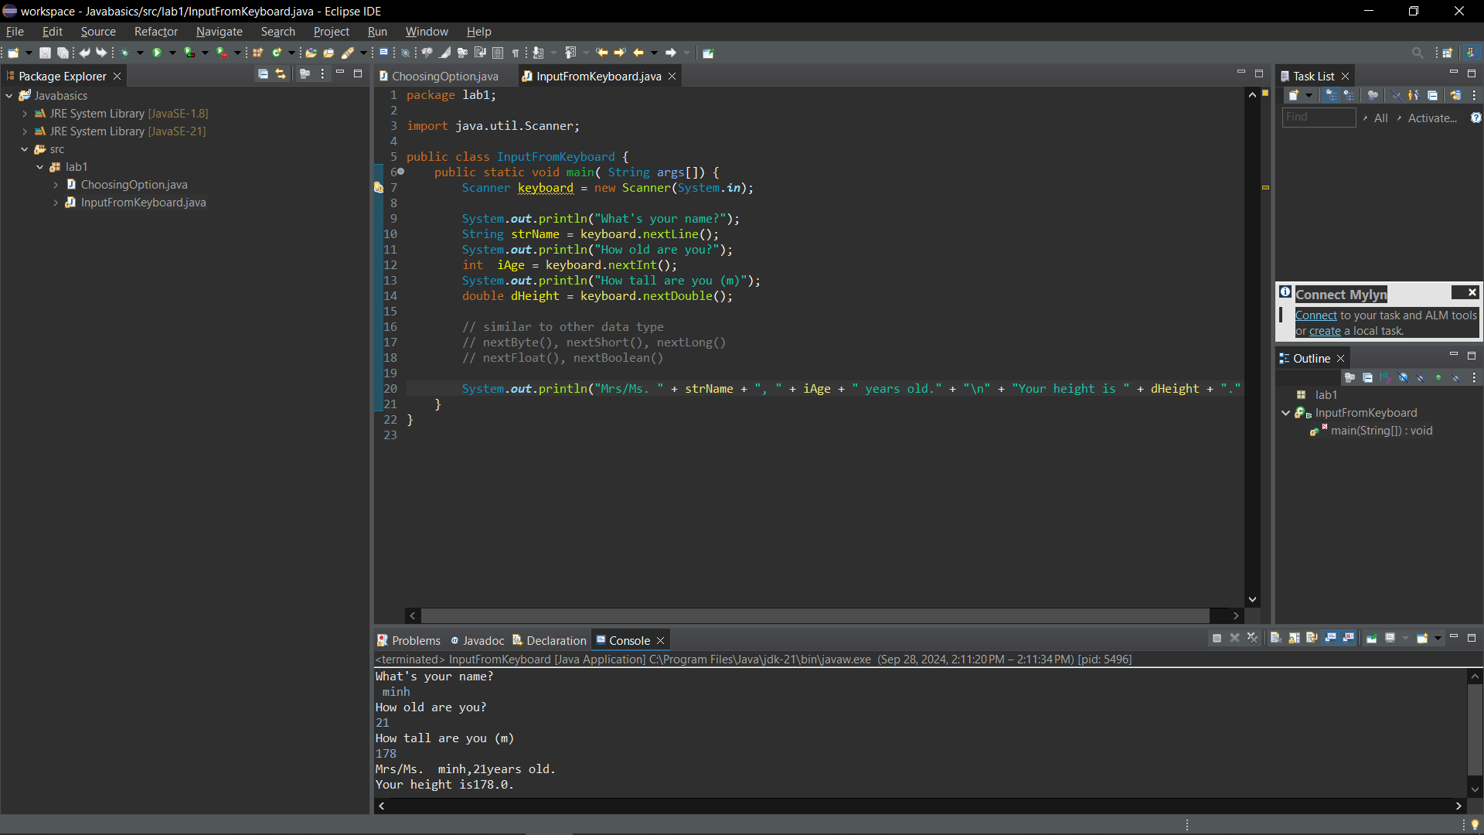

Exercise 3: Write a program to display a triangle with a height of n stars (\*), n is entered by users. 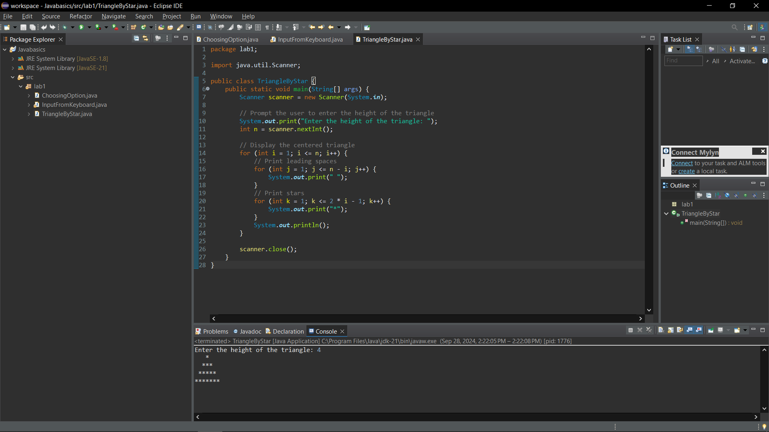

Exercise 4: Write a program to display the number of days of a month, which is entered by users

(both month and year). If it is an invalid month/year, ask the user to enter again.

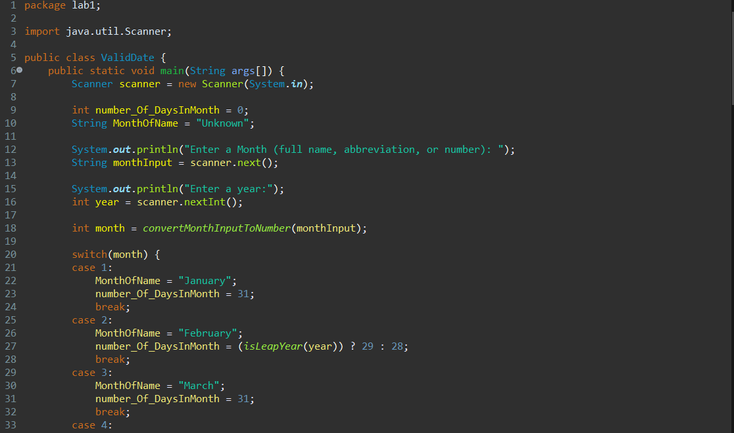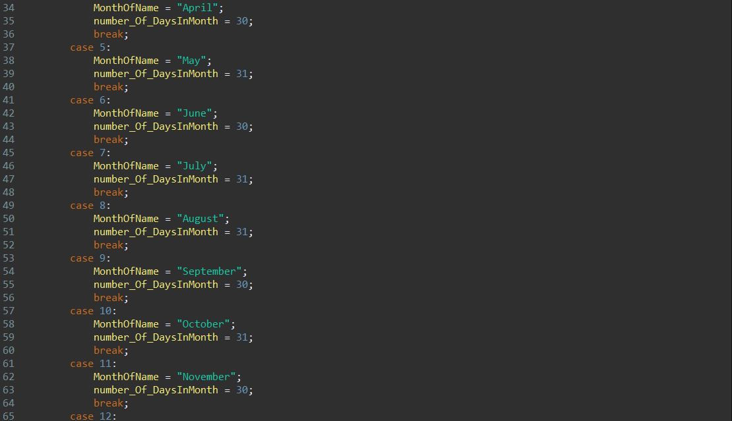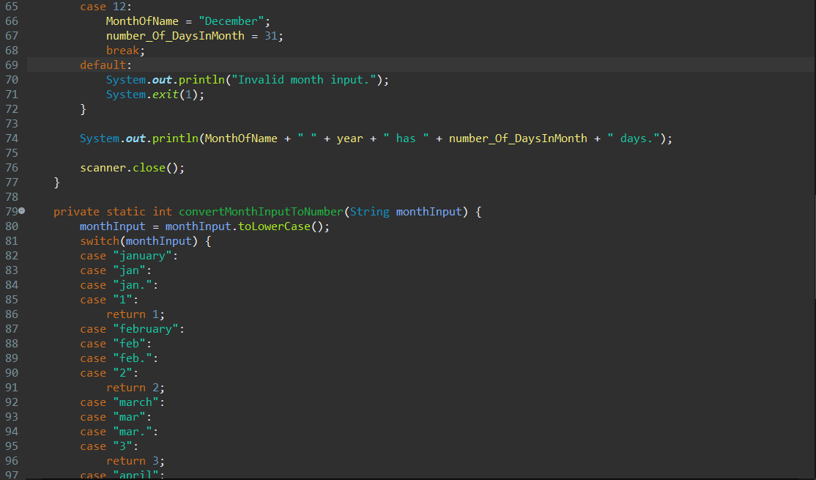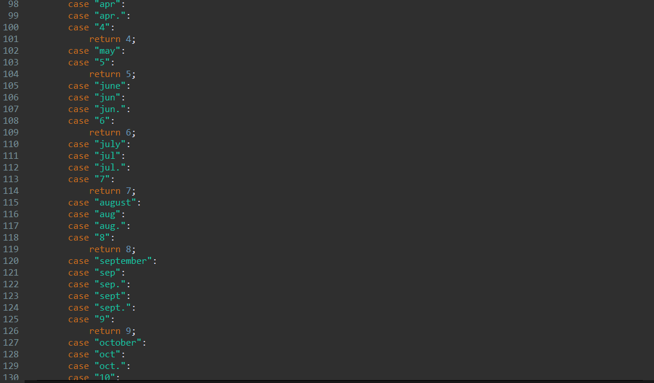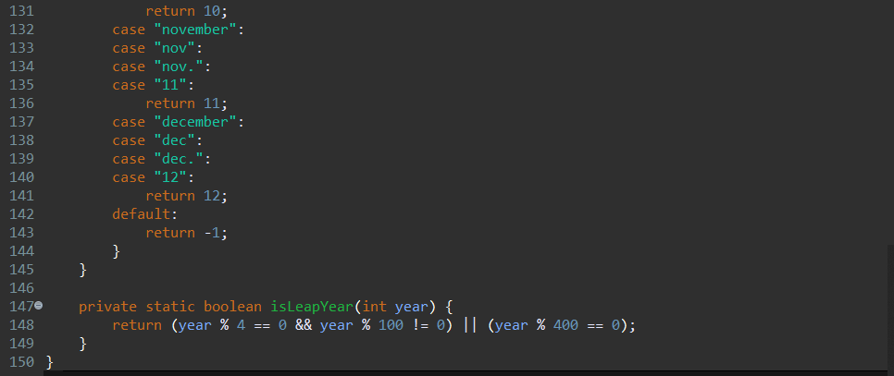

Result:

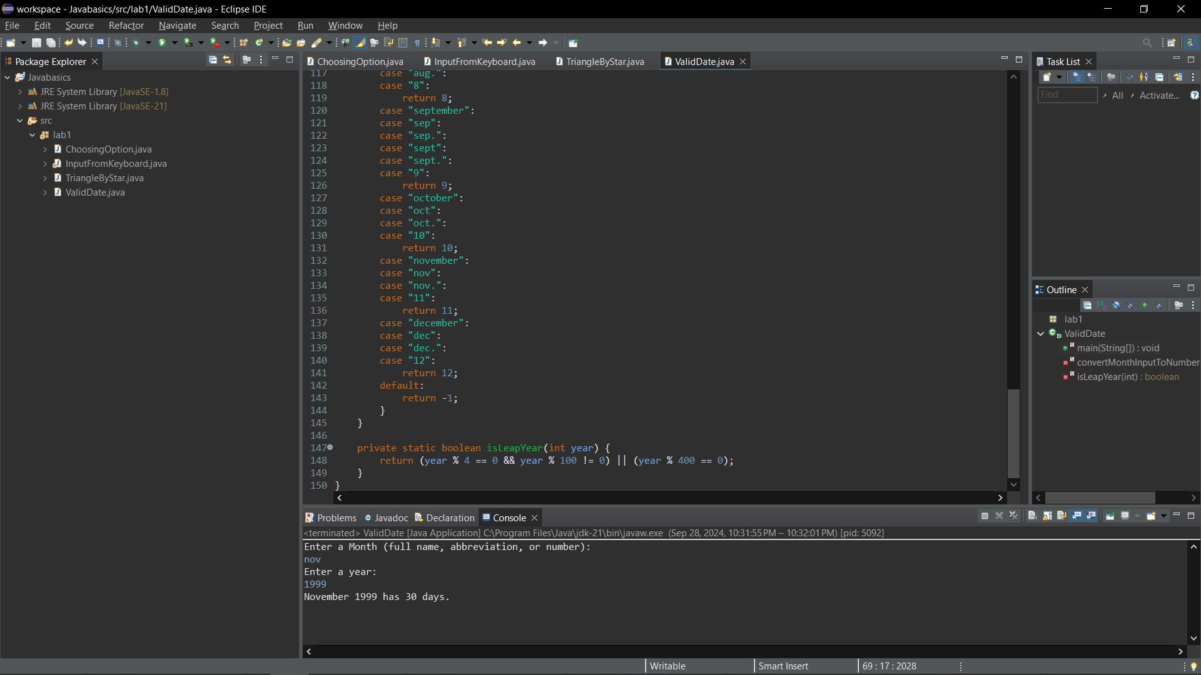

Exercise 5: Write a Java program to sort a numeric array, and calculate the sum and average value of array elements.

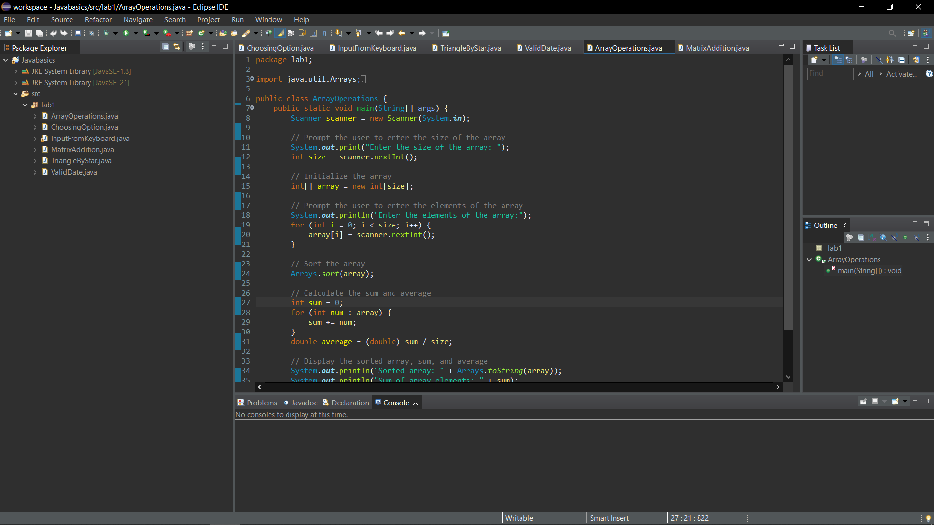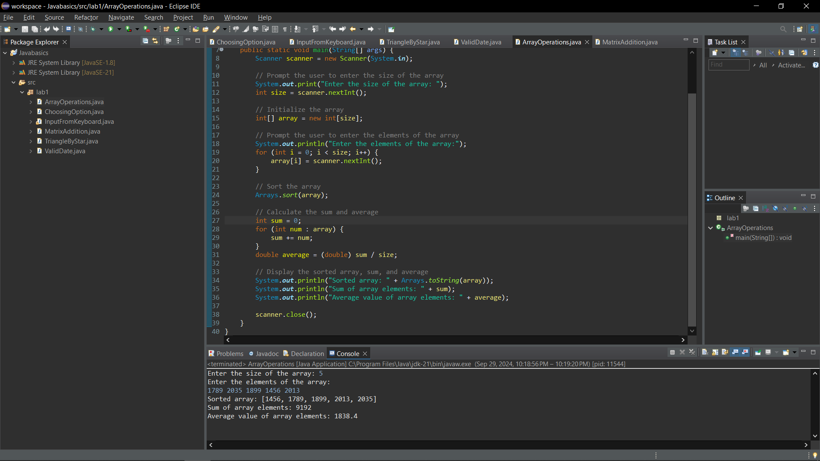

Exercise 6: Write a Java program to add two matrices of the same size.

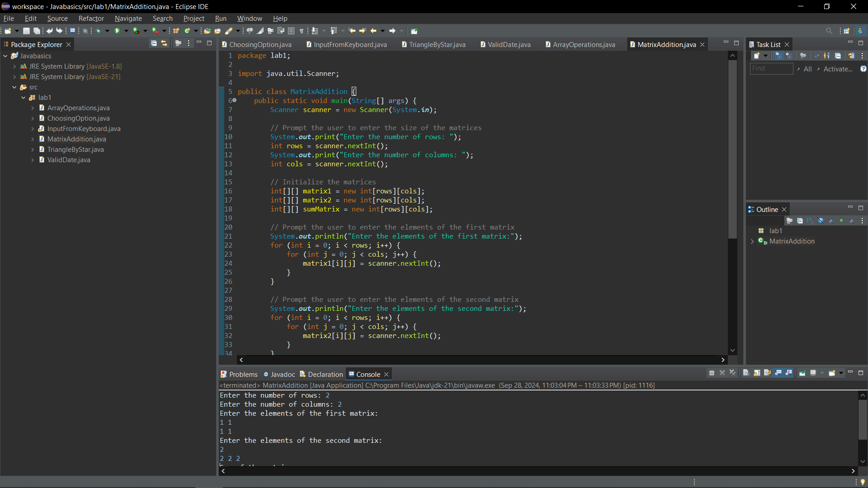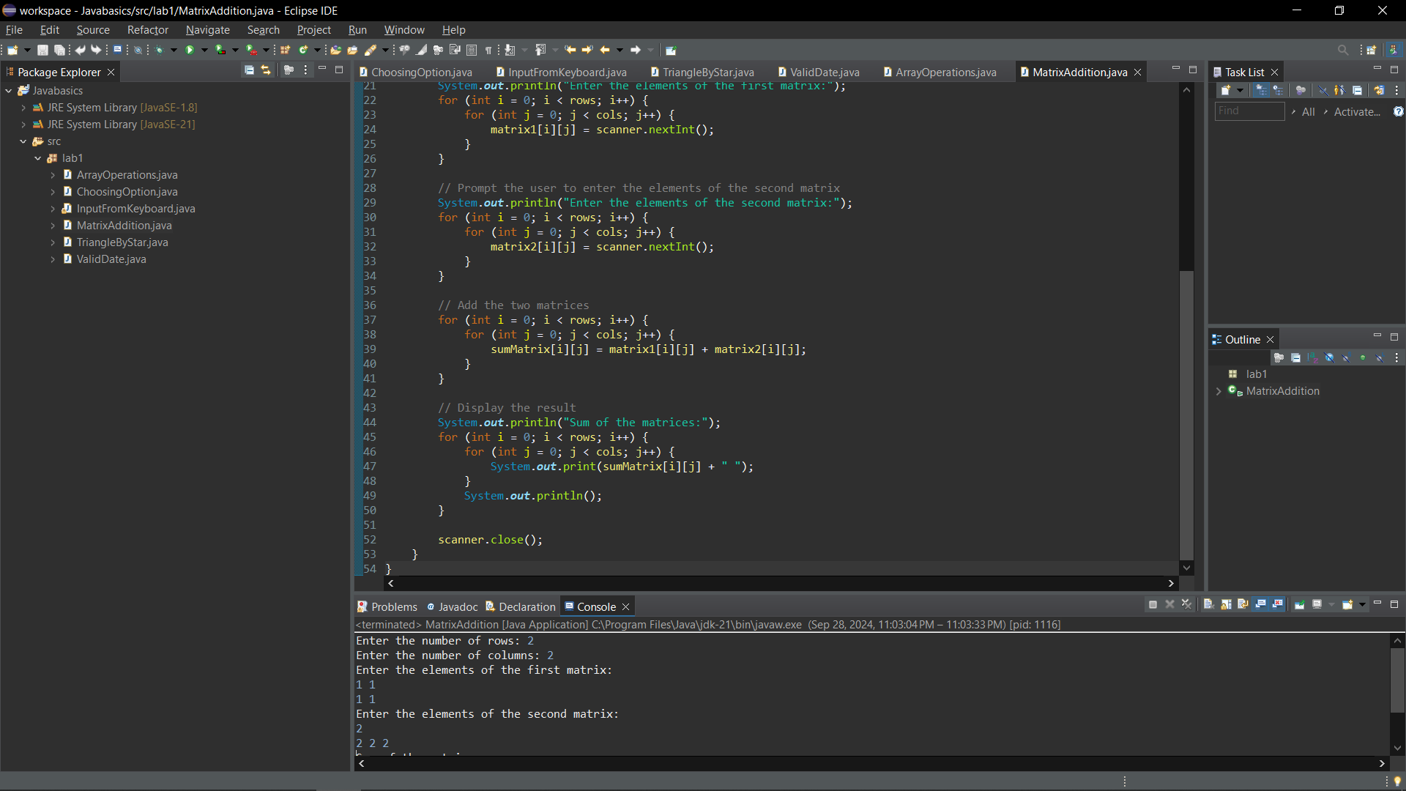

Result:

